Nguyễn Thị Ngọc Mai -22025510

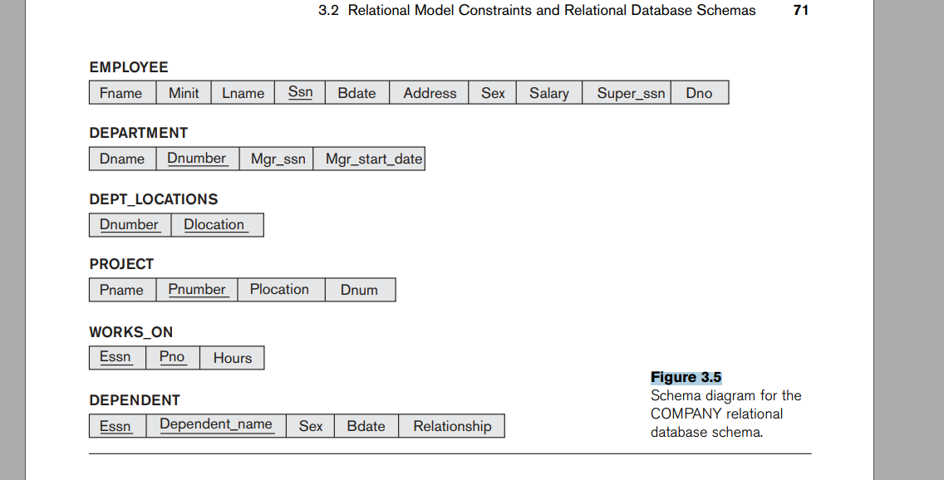

***5.5. Specify the following queries on the database in Figure 3.5 in SQL. Show the***

***query results if each query is applied to the database in Figure 3.6.***

1. For each department whose average employee salary is more than

$30,000, retrieve the department name and the number of employees

working for that department.

SELECT Dname, COUNT (*)

FROM DEPARTMENT, EMPLOYEE WHERE Dnumber = Dno

GROUP BY Dname HAVING AVG (Salary) > 30000

Result:

|  |  |  |
| --- | --- | --- |
| Dname | Dnumber | COUNT (*) |
| Research | 5 | 4 |
| Administration | 4 | 3 |
| Headquarters | 1 | 1 |

1. Suppose that we want the number of male employees in each department

making more than $30,000, rather than all employees (as in Exercise

5.4a). Can we specify this query in SQL? Why or why not?

SELECT Dname, COUNT (*)

FROM DEPARTMENT, EMPLOYEE

WHERE Dnumber = Dno AND Sex = 'Male' AND Dno IN

(SELECT Dno FROM EMPLOYEE

GROUP BY Dno HAVING AVG (Salary) > 30000) GROUP BY Dname

***5.7. In SQL, specify the following queries on the database specified in Figure 3.5 using the concept of nested queries and the concepts described in this chapter.***

1. Retrieve the names of all employees who work in the department that has the employee with the highest salary among all employees.

SELECT Lname FROM EMPLOYEE WHERE Dno =

(SELECT Dno FROM EMPLOYEE WHERE Salary =

(SELECT MAX(Salary) FROM EMPLOYEE))

1. Retrieve the names of all employees whose supervisor’s supervisor has '888665555' for Ssn.

SELECT Lname FROM EMPLOYEE WHERE Supper_ssn IN

(SELECT Ssn FROM EMPLOYEE WHERE Super_ssn = ‘888665555’)

1. Retrieve the names of employees who make at least $10,000 more than the employee who is paid the least in the company.

SELECT Lname FROM EMPLOYEE WHERE Salary >= 10000 +

(SELECT MIN(Salary) FROM EMPLOYEE)